

Empathy Map Canvas

Gain insight and understanding on solving customer problems.

1

Build empathy and keep your focus on the user by putting yourself in their shoes.

giving

bloods to

the need

In the current era its the best way to

make someone feel they too can avoid any critical situation of blood

reducing

the scarcity of blood

must be 18

years of age and weight

atleast 110

pounds

Not a costly 

process

if you want to donate 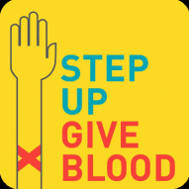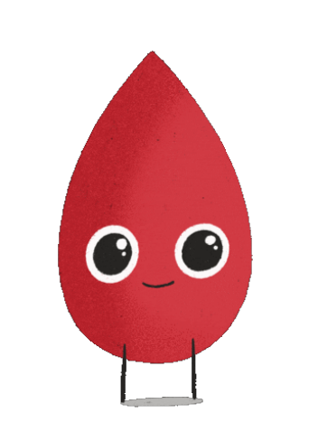

plasma to help others in

need,you will go through

a necessary process.This

is to make sure your

blood is healthy and safe

The decision to donate your blood can

save a life

source

pllasma is a plasma that is collected from

it should be user friendly to use such applications

you can donate plasma every 28 days upto 13 times per year

Having

professiona ; staffs on hand

screening donors for existing

health

conditions

can get the donor quick and fast

Do not need to wait for donors

less time